Cells – How do they carry out the activities of life?

A cell is the smallest living thing. This means that a cell is the smallest thing that can carry out the activities of life. For example, a cell can respond to its environment, use energy, grow, reproduce, and maintain homeostasis (keep things steady inside the cell).

1. Watch the video of an animal cell chasing and then eating bacteria (https://www.youtube.com/watch?v=Z_mXDvZQ6dU). What are two activities of life that are demonstrated by this animal cell?

To carry out the activities of life, each cell has these parts:  - a cell membrane that surrounds the cell and controls what gets into and out of the cell  - DNA, the genetic material, which gives the instructions for making proteins  - ribosomes, the molecular machines that make proteins | 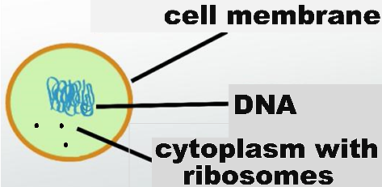
- cytoplasm, including the ribosomes and the cytoskeleton (a network of protein fibers that contribute to the structure and movement of a cell).

Proteins make crucial contributions to the activities of life. For example, molecular changes in the proteins of the cytoskeleton caused the movement of the animal cell as it chased the bacteria. Also, some proteins are:  - enzymes (e.g., enzymes that help the cell to use energy, grow or reproduce)  - pores or pumps in the cell membrane, which | 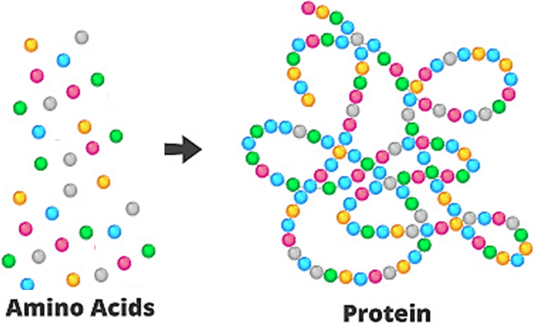
help the cell membrane to maintain homeostasis.

2. Describe how the cell parts listed in this table contribute to the activities of life.

Cell Parts | How These Cell Parts Contribute to the Activities of Life
DNA and ribosomes
Cell membrane

3a. If you ground up cells and put all the molecules from the cells in a test tube, would this mixture of molecules be alive? yes ___ no ___

3b. How do you know?

Animal cells and bacterial cells are examples of two fundamentally different types of cells – eukaryotic cells and prokaryotic cells (see table and figure below).

In a eukaryotic cell, the DNA is surrounded by a nuclear membrane. | In a prokaryotic cell, the DNA is not surrounded by a membrane.
An animal or plant has multiple eukaryotic cells. (There are additional types of organisms that have multiple eukaryotic cells or a single eukaryotic cell.) | A prokaryote is an organism that consists of a prokaryotic cell. Bacteria are one type of prokaryote.

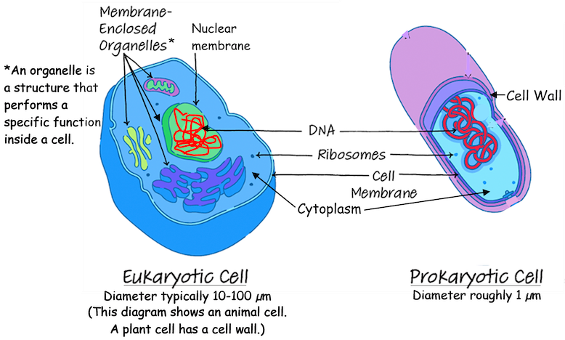

4a. The diameter of a eukaryotic cell is about ____ - ______ times bigger than the diameter of a prokaryotic cell. (Hint: Use the information near the bottom of the figure.)

4b. Draw the outline of a prokaryotic cell that is about 1/10 as wide as the diagram of the eukaryotic cell. This will give a better picture of how much smaller a prokaryotic cell really is.

4c. Eukaryotic cells are bigger than prokaryotic cells, but they are still tiny. View the animation at https://learn.genetics.utah.edu/content/cells/scale/. Which is the biggest?
a grain of salt ___ a red blood cell ___ a skin cell ___

5. Eukaryotic and prokaryotic cells are very different in size and internal structure. Why do both of these types of cells need DNA, ribosomes and a cell membrane?

Some types of prokaryotes can cause diseases (e.g. tuberculosis). However, we would not be better off if we could somehow eliminate all prokaryotes.

For example, we benefit from the roughly 40 trillion prokaryotes that live in our gut and on our skin. These prokaryotes benefit us by making some vitamins and improving our digestion and resistance to infection.

Some prokaryotes have chemical abilities that eukaryotic cells do not have. For example, all organisms need nitrogen (N) atoms in the amino acids in their proteins.  6. Which part of the amino acid requires a nitrogen (N) atom?  amino group ___ carboxyl group ___ both ___  N₂ is abundant in air, but plant and animal cells cannot use N₂. In contrast, some prokaryotes can use N₂ to make NH₄⁺. These prokaryotes use NH₄⁺ to make their amino acids. Fortunately, these | 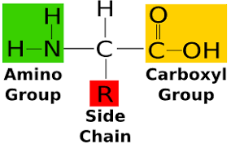  Different amino acids have different side chains. The carboxyl group is the acid part of the amino acid.
prokaryotes produce excess NH₄⁺, which plants can use to make amino acids. Animals get amino acids by consuming proteins in the food they eat.

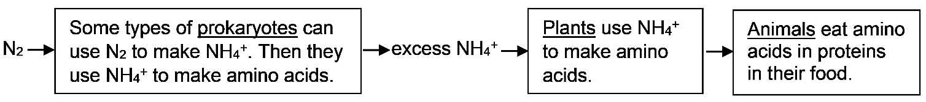

7a. Which type of cells could survive without the other – eukaryotic ___ or prokaryotic ___?

7b. Explain your reasoning.

To review and learn more, watch the video, “Prokaryotic vs. Eukaryotic Cells” (https://www.youtube.com/watch?v=Pxujitlv8wc).

When your body has been infected by disease-causing bacteria or fungi, you may need a medicine to help your body fight the infection. To work well, the medicine should interfere with a molecular process that the infecting cells need, but human cells do not need. For example, an antibiotic interferes with molecular processes needed by bacterial cells, but not needed by human cells. Thus, antibiotics can kill bacteria, without killing human cells.

8. The video states that you need different medications to treat fungal vs. bacterial infections. What is a reasonable conclusion about molecular differences among fungal cells, bacterial cells, and human cells? Explain your reasoning.

An organelle is a structure that performs a specialized function inside a cell. For example, ribosomes make proteins. Eukaryotic cells have several additional types of organelles. These organelles are surrounded by membranes.
- The nucleus contains the DNA which gives the instructions for making proteins.
- In a eukaryotic cell, some of the ribosomes are attached to the membranes of the rough endoplasmic reticulum. These ribosomes produce proteins that will be secreted from the cell (e.g., protein hormones) or will become part of the cell membrane (e.g., protein pumps). These proteins are prepared for secretion or insertion in the cell membrane by processing in the rough endoplasmic reticulum and the Golgi apparatus.
- Mitochondria make ATP, which provides the energy needed for many cellular processes.
- In animal cells, lysosomes contain enzymes that digest worn out cellular materials. These enzymes also digest any bacteria eaten by a cell.

9a. This diagram shows an animal cell. Several of the organelles work together to make and
process proteins that will be secreted from the cell. Next to the name of each of these organelles, briefly describe its function.  9b. Circle the name of the organelle that makes the ATP that provides the energy for protein production and secretion. | 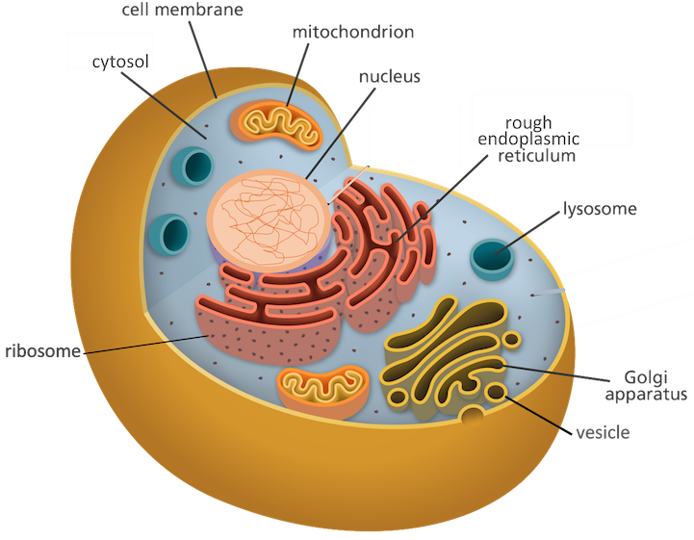

This figure shows how proteins that will be secreted from the cell are transported from the rough endoplasmic reticulum to the Golgi apparatus and from the Golgi apparatus to the cell membrane. A vesicle, with proteins inside it, is carried by a motor protein that walks along a microtubule. (Microtubules are part of the cytoskeleton.) Once a vesicle reaches the cell membrane, the vesicle membrane merges with the cell membrane, and the contents of the vesicle are secreted (see figure on the next page). |  | 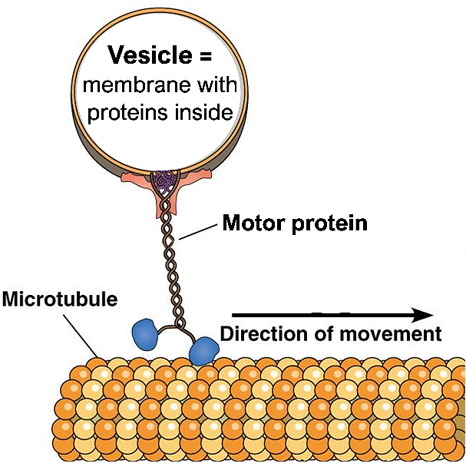
This figure shows that vesicles carry proteins from the rough endoplasmic reticulum (rough ER) to the Golgi apparatus and from the Golgi apparatus to the cell membrane. The vesicle membrane merges with the cell membrane, so the proteins that were inside the vesicle are secreted from the cell.  10. How are these vesicles moved inside a cell? | 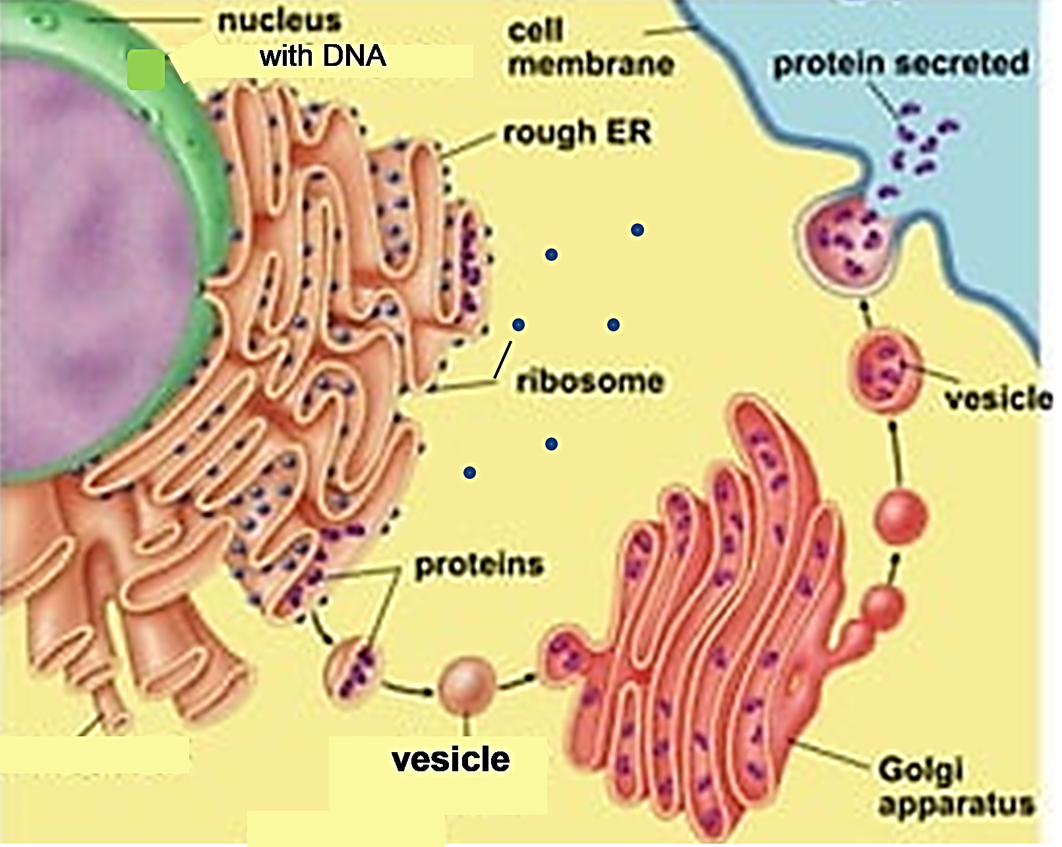

11. The different parts of a eukaryotic cell work together to accomplish the cell’s functions. Some eukaryotic cells can be thought of as factories that make protein hormones and secrete them. Which parts of the cell accomplish each of the functions listed in the table below?

Factory (Cell) Function | What part or parts of the cell  accomplish this function?
Management – sends out instructions (DNA –>
RNA) for making each product (protein)

Workbench – uses instructions to make products (RNA – > proteins)

Processing – prepares products (proteins) to
leave factory (cell)

Transport – moves products (proteins) inside the
factory (cell)

Security Fence with Gates – controls what
comes into or leaves the factory (cell)

Powerhouse – provides energy in a form the
factory (cell) can use (ATP)

Cleanup crew – disposes of worn out
equipment and products

To see an animation that illustrates some of the constant activity inside a cell, watch from about 3 minutes and 45 seconds to 6 minutes and 40 seconds in the video, “The Inner Life of the Cell” (https://www.youtube.com/watch?v=6wGAVxe7cik). This recommended segment shows how (1) vesicles are transported by motor proteins walking along the microtubules of the cytoskeleton and (2) proteins are synthesized by ribosomes and some proteins are processed in the rough endoplasmic reticulum and Golgi apparatus. Don’t worry if you don’t understand everything the narrator says.
One advantage of being multicellular is that different cells can specialize for different activities of life. For example, human sperm cells are specialized for sexual reproduction in a multicellular organism. Sperm have a specialized structure that helps them reach and fertilize an egg.
12a. Explain how the flagellum of a sperm cell contributes to sperm function. (Hint: View swimming sperm at https://sites.tufts.edu/guastolab/movies/.) | 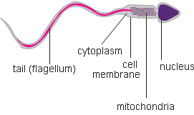

12b. Explain why it is an advantage for a sperm cell to have very little cytoplasm and lots of mitochondria.

12c. In biology, structure is related to function. Structure includes the shape of a cell, which parts the cell has, and how the parts are organized. Give an example of the relationship between structure and function in sperm.

The animal cell in the introductory video was a phagocyte, a type of white blood cell that defends our bodies against infection by killing bacteria. Phagocytes move out of the blood in the capillaries (the smallest blood vessels). Phagocytes squeeze between the cells of the capillary wall and move toward an infected injury. Then, phagocytes engulf the bacteria. The chemicals and enzymes in the phagocytes’ lysosomes kill and digest the bacteria.
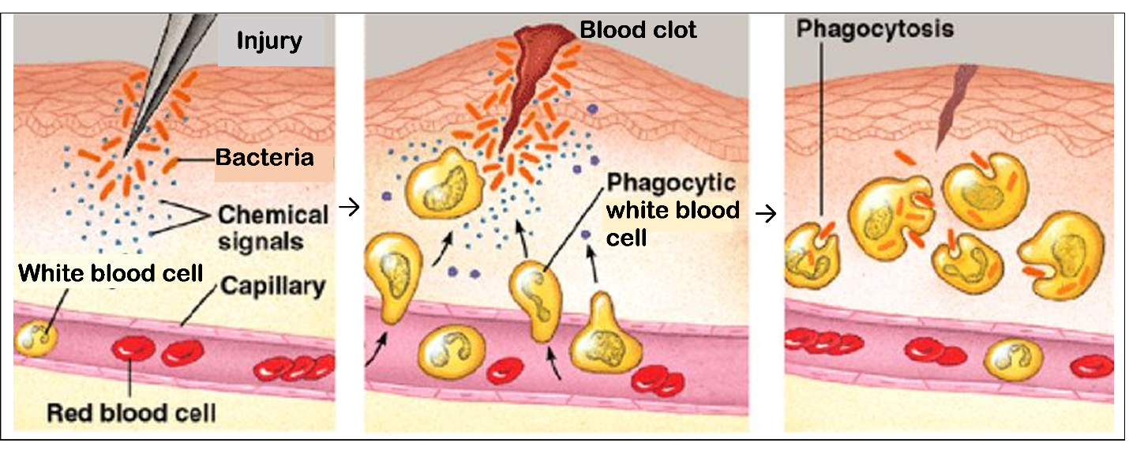
13a. Why do phagocytes need to be able to change shape in order to accomplish their function?

13b. Each phagocyte has more lysosomes than a typical animal cell. Explain how these lysosomes help a phagocyte to accomplish its function.

Many parts of plant cells are also found in animal cells, but plant cells have several additional cell parts. Specifically, plant cells have:
- chloroplasts, which use light energy, CO₂ and H₂O to make sugars,
- cell walls and central vacuoles, which together provide structural support for the plant.

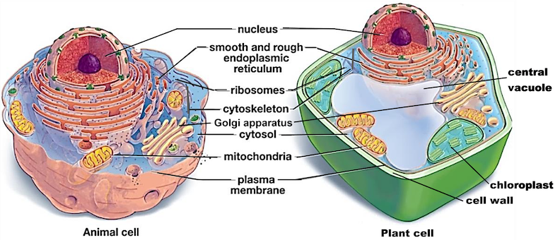

14. In the diagram of the plant cell, draw an arrow from the organelle that makes sugars to the organelle that uses sugars in a process that makes ATP.

15. Explain why the structures listed in the table are useful for plant cells, but not needed or even a disadvantage for animal cells.

 | Why These Parts  are Useful in Plant Cells | Why These Parts Are Not Needed in Animal Cells or Even a Disadvantage for Animal Cells
Chloroplasts
Cell wall and central vacuole

16. Fill out this Venn diagram; in appropriate areas, list cell parts that are found only in eukaryotic cells or found in both eukaryotic and prokaryotic cells. Put an asterisk (*) next to cell parts that are found in plant cells, but not in animal cells.
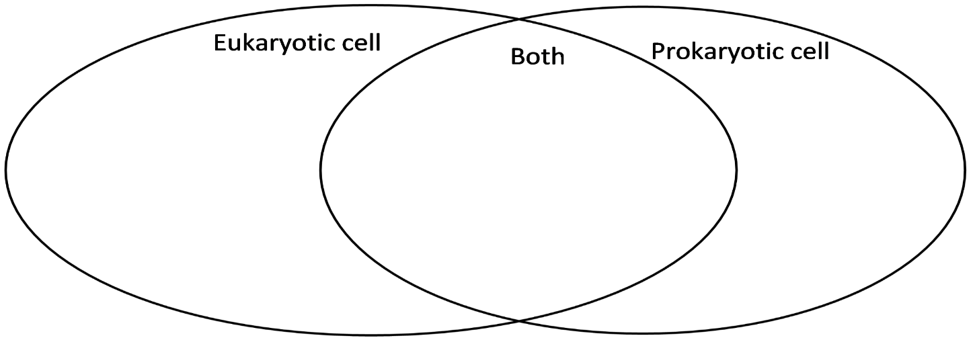

By Dr. Ingrid Waldron, Dept Biology, Univ Pennsylvania, © 2025. This more complete Student Handout, a simpler Student Handout, and Teacher Notes with instructional suggestions and background biology are available at https://serendipstudio.org/exchange/bioactivities/Cells.

